4b. Implement queue using two stacks in an efficient method:
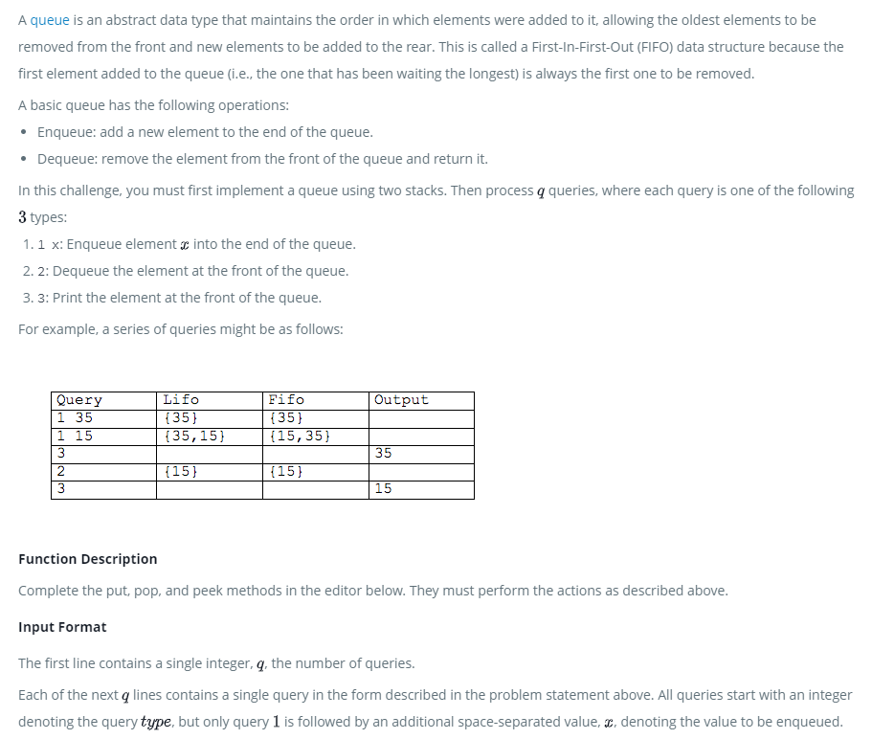

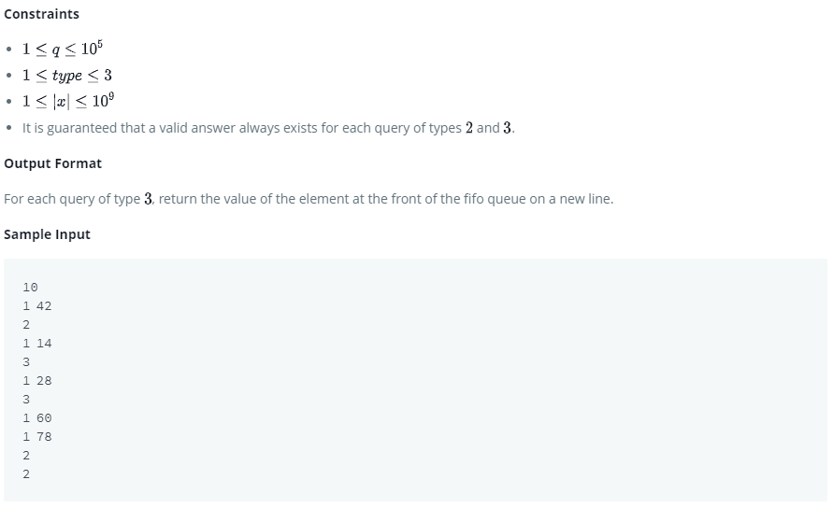
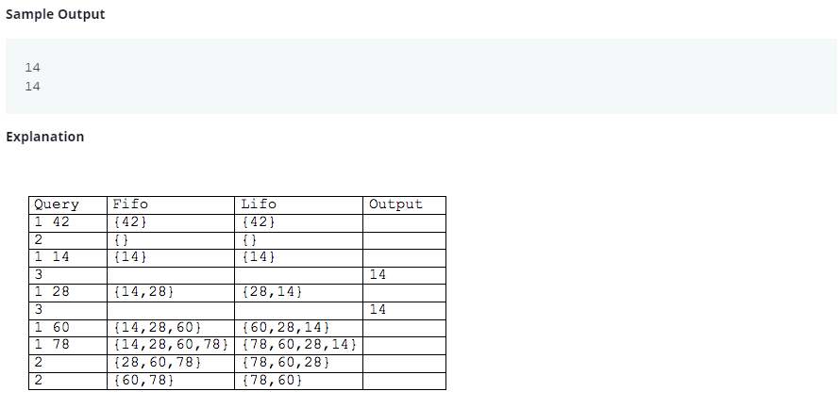
Code:
#include <cmath>
#include <cstdio>
#include <vector>
#include <iostream>
#include <algorithm>
#include <stack>
#include <queue>
using namespace std;

class MyQueue {

public:
stack<int> s1, s2;
int frontInS1;
void push(int x) {
if(s1.empty()) frontInS1 = x;
s1.push(x);
}

void pop() {
if(s2.empty()) {
while(!s1.empty()) {
s2.push(s1.top());
s1.pop();
}
}
s2.pop(); // s2.pop() should be outside if(s2.empty())
}

int front() {
if(s2.empty()) return frontInS1;
else return s2.top();
}
};

int main() {
MyQueue q1;
int q, type, x;
cin >> q;

for(int i = 0; i < q; i++) {
cin >> type;
if(type == 1) {
cin >> x;
q1.push(x);
}
else if(type == 2) {
q1.pop();
}
else cout << q1.front() << endl;
}
/* Enter your code here. Read input from STDIN. Print output to STDOUT */
return 0;
}

